Title: | AEP QRO.  Window Lifter
Authors: Habib Alejandro Apez González.
Estefanía López Villagómez.

History
Issue status  (Index) | Maturity/Date  (draft/invalid/valid)  (dd-mmm-yyyy) |  | Author  Department | Check/Release  Department | Description
1 | Draft  20-Oct-2017 | Habib Apez.  Estefanía López. |  | Continental Engineers and authors. | Initial Draft
2 | Draft  23-Oct-2017 | Habib Apez.  Estefanía López. |  | Continental Engineers and authors. | SW conceptual design section diagrams added.
3 | Draft  25-Oct-2017 | Habib Apez.  Estefanía López. |  | Continental Engineers and authors. | Component breakdown and flow diagrams added.
4 | Draft  26-Oct-2017 | Habib Apez.  Estefanía López. |  | Continental Engineers and authors. | Function descriptions completed.
5 | Valid  27-Oct-2017 | Habib Apez.  Estefanía López. |  | Continental Engineers and authors. | First Release.
6 | Draft  02-Nov-2017 | Habib Apez.  Estefanía López. |  | Continental Engineers and authors. | Corrections based on feedback´s group included.
7 | Valid  03-Nov-2017 | Habib Apez.  Estefanía López. |  | Continental Engineers and authors. | Second Release.
1 | Draft  23-Nov-2017 | Estefanía López. |  | Continental Engineers and authors. | Finite State Machine and Scheduler apply, initial Draft
2 | Draft  25-Nov-2017 | Estefanía López |  | Continental Engineers and authors | Diagrams added of some components for can go to do the code.
3 | Valid  26-Noviembre-2017 | Estefanía López |  | Continental Engineers and authors | Corrections, diagrams added, description of functions, final deliverable.

Table of Contents

CHAPTER | TITLE | PAGE
1.  2. | PURPOSE ……………………………………………………………………………………………………  DEFINITIONS AND ABBREVIATIONS ……………………………………………………………. | 5  5
2.1 | Definitions ………………………………………………………………………………………………… | 5
2.2 | Abbreviations ……………………………………………………………………………………………… | 6
2.3 | References …………………………………………………………………………………………………. | 6
3. | REALIZATION CONSTRAINTS AND TARGETS ………………………………………………… | 6
4. | SW CONCEPTUAL DESIGN ……………………………………………………………………………. | 7
4.1 | State Machine Window Lifter Block Diagram.……………………………………………….
4.2 | Implementation Block Diagram …………………….………………………………………………
4.3 | Window Lifter Implementation …………………………………………………………………….
5. | SW COMPONENT INTERNAL BREAKDOWN ……………………………………………………
5.1  5.2  5.3  5.4  5.5  5.6  5.7  5.8 | IDLE……………………………………………………………………………………………………………….  UP_MANUAL…………………………………………………………………………………………………  DOWN_MANUAL…………………………………………………………………………………………..  ONE_TOUCH_UP……………………………………………………………………………………………  ONE_TOUCH_DOWN……………………………………………………………………………………..  ANTIPINCH………………………………………………………………………………………………….…  LOCK……………………………………………………………………………………………………………..  Functional decomposition……………………………………………………………………………..
5.8.1  5.8.2 | Main function decomposition at APP layer………………………………………………….…  Main function decomposition at APP & HAL layer…………………………………….……
5.8.3  6.  6.1  6.2  6.3  6.3.1  6.3.1.1  6.3.1.2  6.3.1.3  6.3.1.4  6.3.1.5  6.3.1.6  6.3.1.7  6.3.1.8  6.3.1.9  6.3.2  6.3.2.1  6.3.2.2 6.3.2.3  6.3.2.4  6.3.2.5  6.3.2.6 | Window Lifter Flow Diagram……………………………………………………………………….…  FUNCTION DESCRIPTION AND DYNAMIC BEHAVIOR………………………………………  MCAL…………………………………………………………………………………………………………….  HAL……………………………………………………………………………………………………………….  APP……………………………………………………………………………………………………………….  Windowlifter.c …………………………………………………………………………………………….  Function void windowlifter_IdleState(void) ………………………………………………  Function void windowlifter_OneTouchUpState(void) ……………………………….  Function void windowlifter_UpNormalState(void) ……………………………………  Function void windowlifter_OneTouchDownState(void) …………………………  Function windowlifter_DownNormalState(void) ………………………………………  Function void windowlifter_AntipinchState(void) ……………………………………  Function void windowlifter_BlockState(void) …………………………………………  Function void windowlifter_StateMachine(void) ……………………………………  Buttonsm.c …………………………………………………………………………………………………  Function void buttonsm_StateMachine(void) ……………………………………………  Function void buttonsm_IdleState(void) ……………………………………………………  Function void buttonsm_DownValidationState(void)…………………………………  Function void buttonsm_UpValidationState(void) ……………………………  Function void buttonsm_AntipinchValidationState(void)……………………..

Purpose

A power window lifter is an automobile part which can be manipulated to up or down and other specific safety use control.

This project will work using three push buttons, one for the up movement, the other one for down and the third for the antipinch, these specific buttons are going to order to our hardware to simulate the window movement represented with a ten segment red light bar, this light will turn on to be a complete close window or turn off to get down as the user will wanted.

Each button have two modes, manual and one touch. The first one works to make all the track if you press for determinate time, and the second one is for only a part of the track with a quick movement.

There is too an extra function: Anti pinch this is a safety requirement than works only when the up movement is activated to prevent some kind of accidents, this stops the other move and make than our window down partially and remain stop for 5 seconds, then all our normal process continues again.

The process our all the functions are scheduled in layers: MAL, HAL, APP. To simplify the final operations and delimit the functions with the option to continue adding other future operations.

Too, the window lifter will be implemented as a state machine, inside of a scheduler module, this module will have six tasks working in the same line of time, and our state machine will be applied in one of them as our main function.

The state machine contains an IDLE state and a LOCK state extra to the normal functions: One Touch Up, One Touch Down, Up, Down and Antipinch with the finality to make better the operations with the user.

Definitions and abbreviations

Definitions

Abbreviation | Definition
MCAL  HAL | Microcontroller Abstraction Layer  Hardware Abstraction Layer
APP | Application Layer
SW | Software
HW | Hardware
GPIO | General Purpose Input/Output
LPIT  IDLE | Low Power Interrupt Timer  Not working or active
LOCK | A device for securing a door
PORT | Port Control and Interrupts

Abbreviations

s | Second
Ms  FST | Milisecond  Finite State Machine

References
N° | Document name | Reference
1 | Window lifter requirements.docx | Continental
2 | V_Cycle Process | Continental
3 | V_Cycle Process Script.xlsx | Continental
4 | S32K1xx Series Reference Manual | NXP
5 | Naming Conventions.pdf | Continental
6 | https://www.iar.com/iar-embedded-workbench | IAR
7 | MISRA C:2012 March 2013 | Continental
8 | S32K1xx Data sheet | NXP
9 | Finite State Machines for software development | Continental
10 | Scheduler Design and Implementation | Continental

Realization constraints and targets

Window Lifter:

The principal purpose is controlling a simulation window movement.

It will going to work with the interface of 3 different buttons, one will do the action to up in the modality of one touch and manual, the other one will do the down in one touch and manual, and the extra will do the Antipinch mode.

There is going to be appreciable de action using a light to indicate it, blue to Up, Green to Down and Red to Antipinch.

Our Scheduler module will be refer to making a sequence of time execution decisions at specific intervals where our six tasks will be running with its specific mask and offset to mark the execution, and make it available to another applications use partitioning mechanisms to bind our tasks the time real operation for each personal, if the task is empty, the will be running in an idle state; functions, and when the tasks are no been executed the processor is running a Background Task.

The specification is than our system will be working as a state machine to make the functions in states defined for the right use in case that our costumer requested.

One restriction of the requirements is than this project only can have a ten segment bar led to simulate the movement. And other restriction is the use of the board S32K144EVB-Q100.

SW Conceptual design

General window lifter system, it specifies the actions of the application accommodated in a State Machine with the interaction of the different states and the corresponding functions on each case than they will going to do as the user wanted, to can make than the window lifter be interactive with the user.

There is too the Scheduler part, where in our module of programmed will be working our operational system, to execute the rest of the other tasks to make our application more complete and real.

State Machine Window Lifter Block Diagram

General

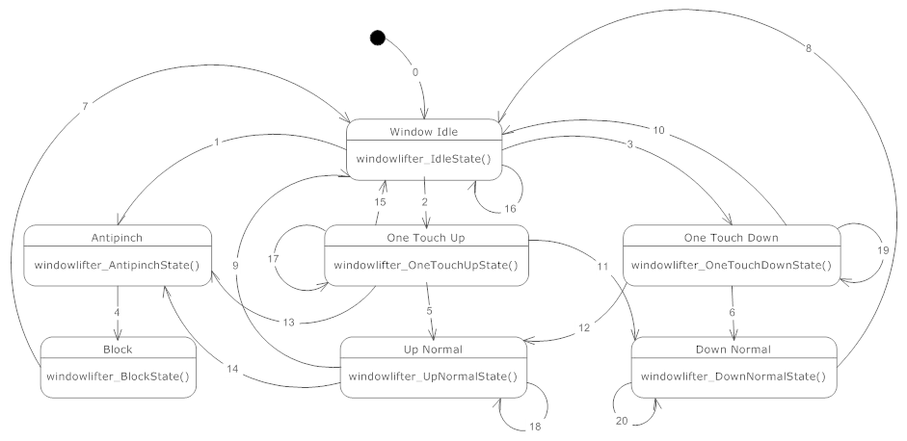
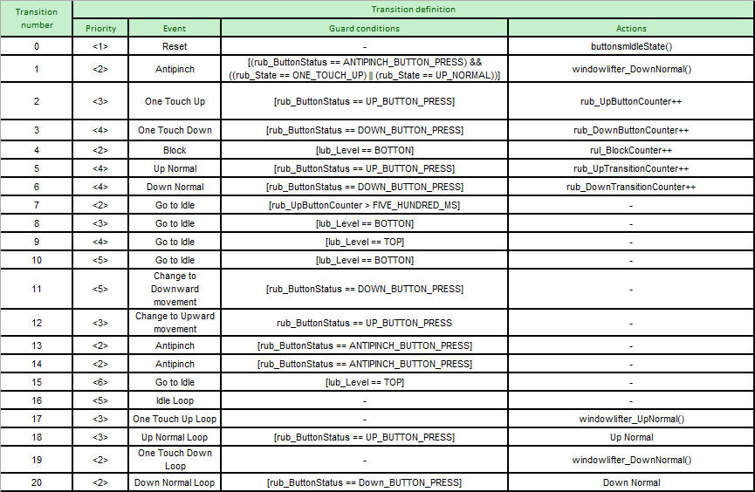

State Machine Button Validation Block Diagram

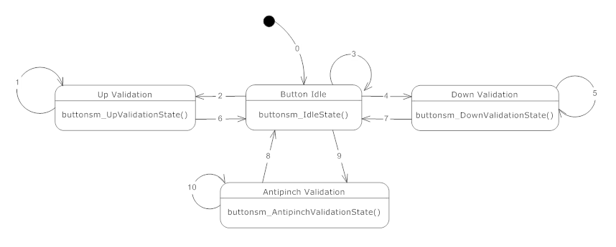
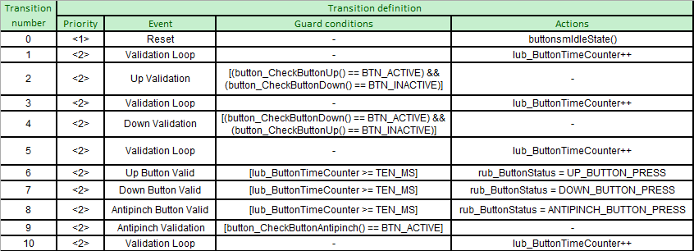

Scheduling Design
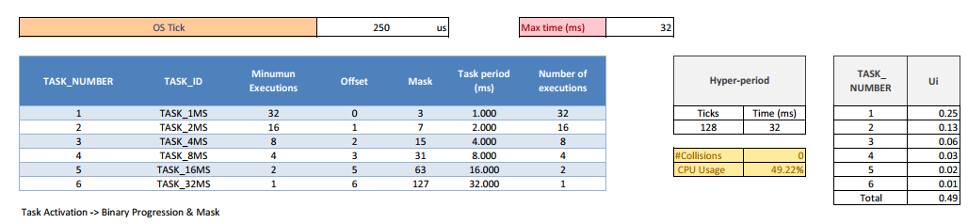

Implementation Block Diagram
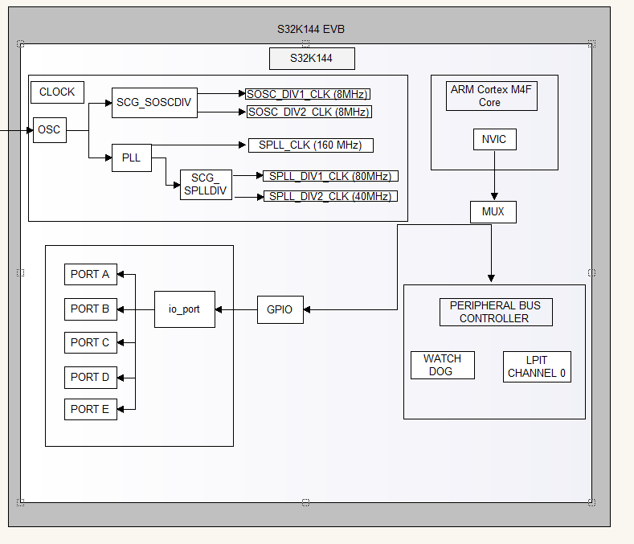

Window Lifter Implementation

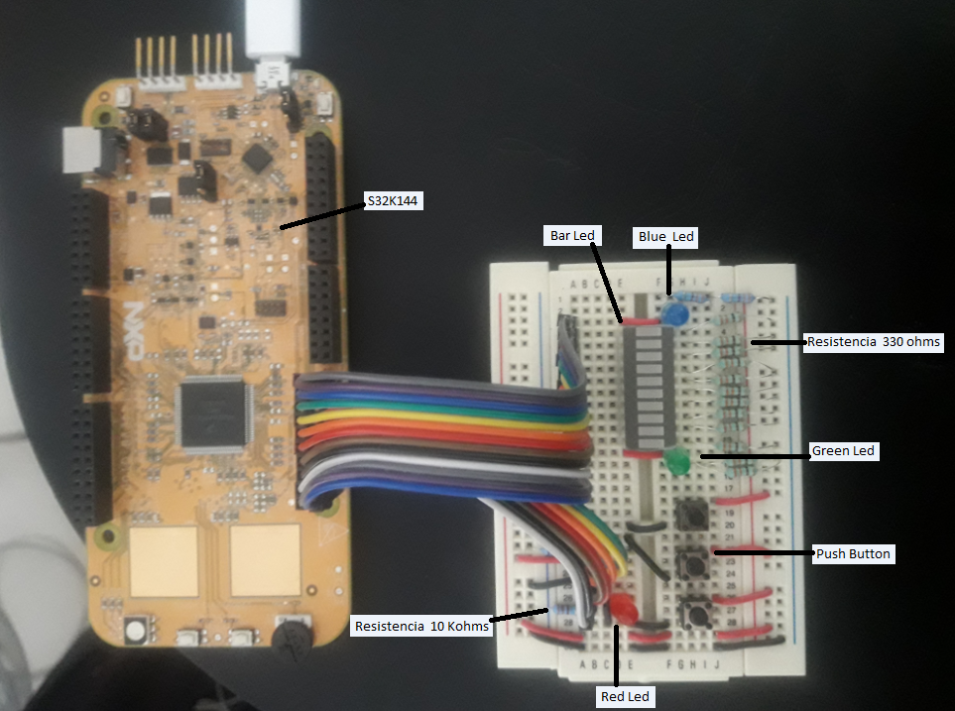

SW Component internal breakdown

In this section, the main functions in APP are described through a block diagrams. Each diagram shows the relation between that component and other components located in HAL and MCAL. Also describes the part of the Scheduler as far as it concerns.

Functional Decomposition
Main function for the window lifter. Dependencies between main() and other functions in APP layer are shown in the following diagram.

Main function descomposition at APP level

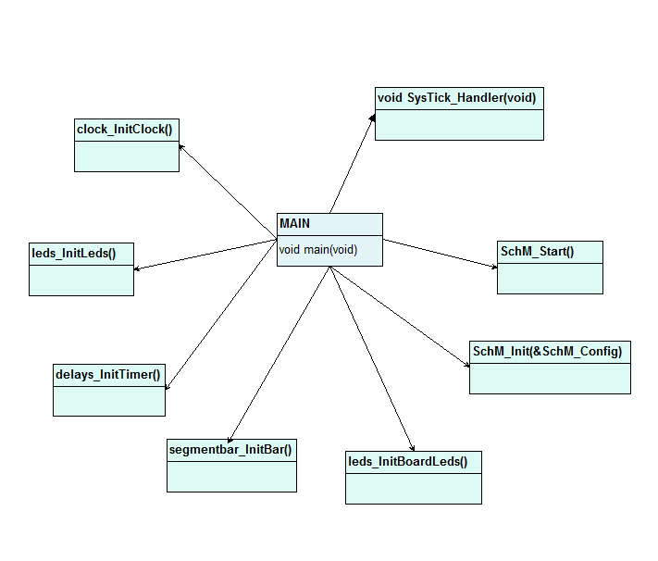

Function Description and Dynamic Behavior
The following image shows the modules developed and their corresponding layer.

MCAL
MCAL has several modules such as: io, lpit, pcc, wdt, port and scg. The following image shows how each of these modules are conformed. Each module maps a set of registers of the microcontroller.

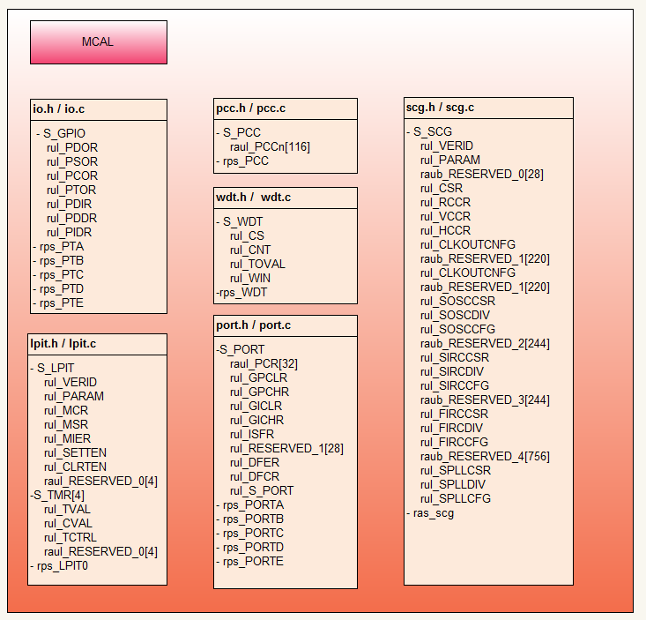

HAL

The modules to interact with the hardware are specified in MCAL. This layer contains the following modules: segmentbar, button, leds, timer and clock. The functions of each module are shown in the following figure.

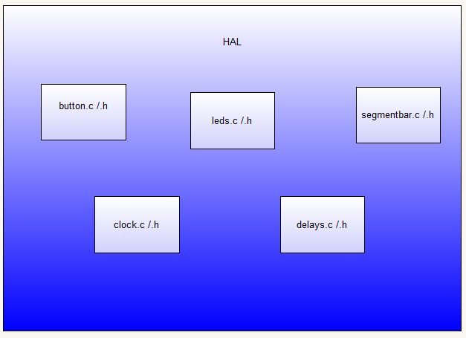

Services Scheduler

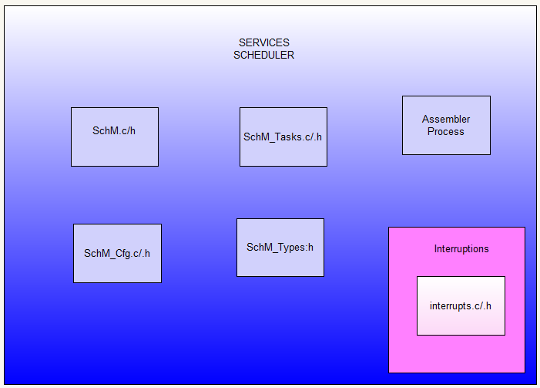

APP
APP contains five functions that allow the window’s movements and the main(). The following figure shows APP’s structure.

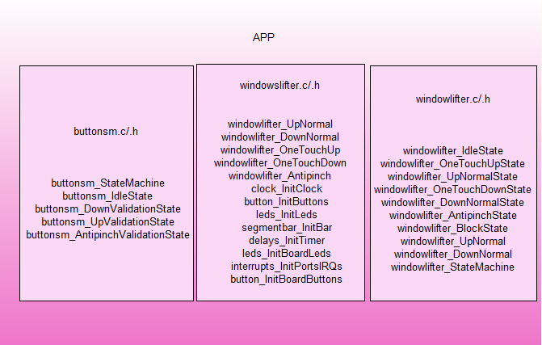

Windowlifter.c

Function void windowlifter_IdleState(void) [DSD-1]

Description | This function is the representation of Idle State in the FSM this is used to execute when no other function is active, without entering the state of suspension
Parameter 1 | None
Return Value | void
Precondition | Scheduler running, buttonsm_StateMachine(void)
Post condition | Idle state in our application
Error Conditions | None

Dynamic Behavior
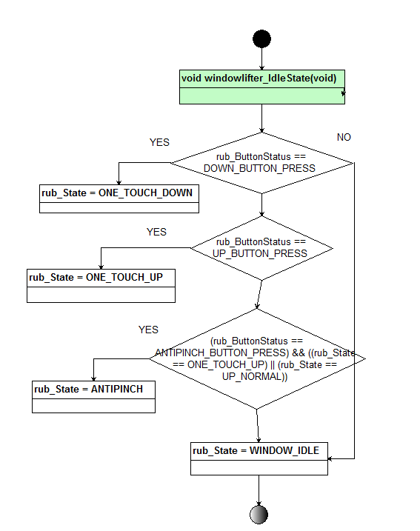

Function void windowlifter_OneTouchUpState(void) [DSD-2]

Description | This function defines the Up Normal State, where the where the user can perform the action of uploading as much as they wanted. Moves the window uploading until it reaches the CLOSED stage, it can call multiple time to windorlifter NormalUP.
Parameter 1 | None
Return Value | void
Precondition | Scheduler running, buttonsm_StateMachine(void)
Post condition | One Touch Up State
Error Conditions | None

Dynamic Behavior

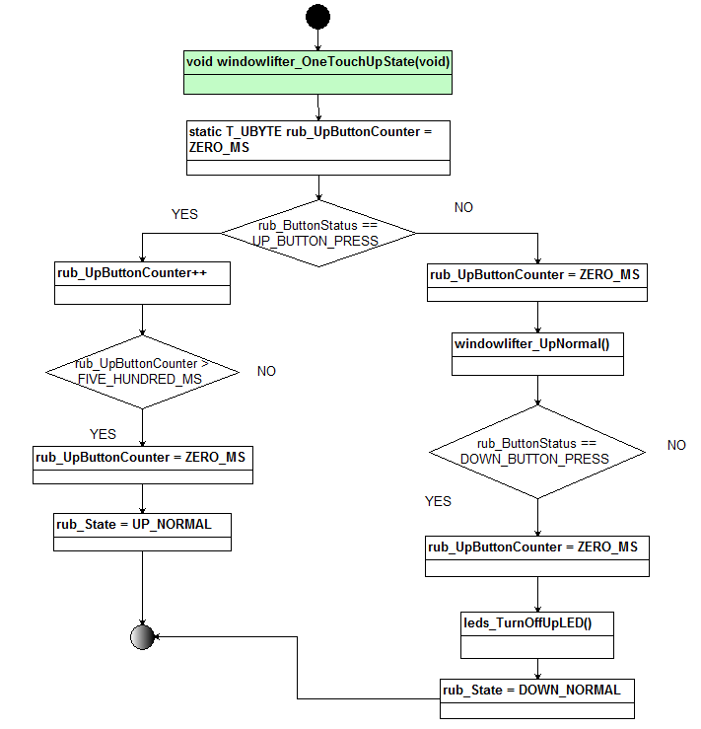

Function void windowlifter_UpNormalState(void) [DSD-3]
Description | This function defines the Up Normal State, where the where the user can perform the action of uploading just one stage.
Parameter 1 | None
Return Value | void
Precondition | Scheduler running, buttonsm_StateMachine(void)
Post condition | Up Normal State
Error Conditions | None

Dynamic Behavior

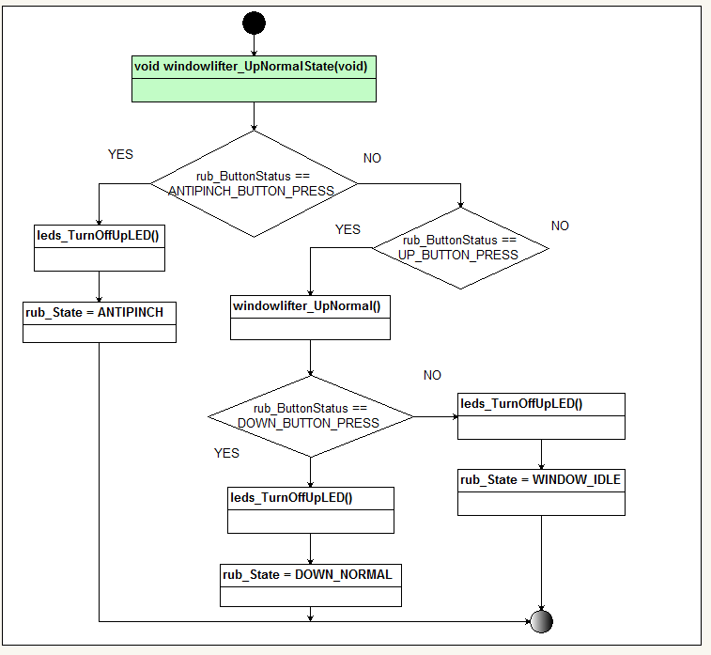

Function void windowlifter_OneTouchDownState(void) [DSD-4]
Description | This function defines the Down Normal State, where the where the user can perform the action of downloading as much as they wanted. Moves the window uploading until it reaches the OPEN stage, it can call multiple time to windorlifter NormalDown.
Parameter 1 | None
Return Value | void
Precondition | Scheduler running, buttonsm_StateMachine(void)
Post condition | One Touch Down State
Error Conditions | None

Dynamic Behavior
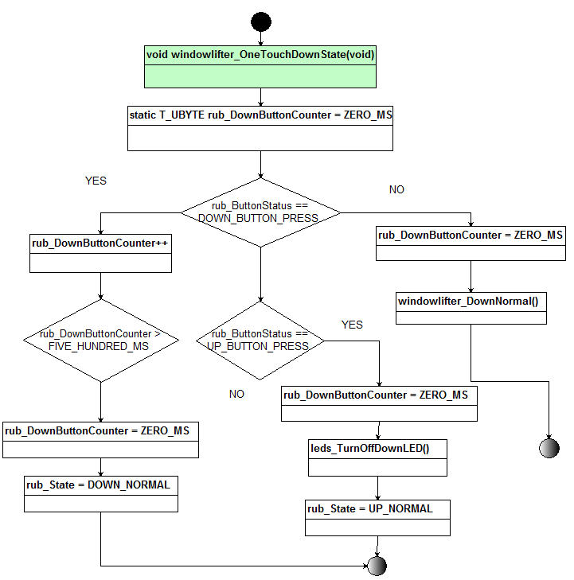

Function windowlifter_DownNormalState(void) [DSD-5]
Description | This function defines the Down Normal State, where the where the user can perform the action of downloading just one stage
Parameter 1 | None
Return Value | void
Precondition | Scheduler running, buttonsm_StateMachine(void)
Post condition | Down Normal State
Error Conditions | None

Dynamic Behavior

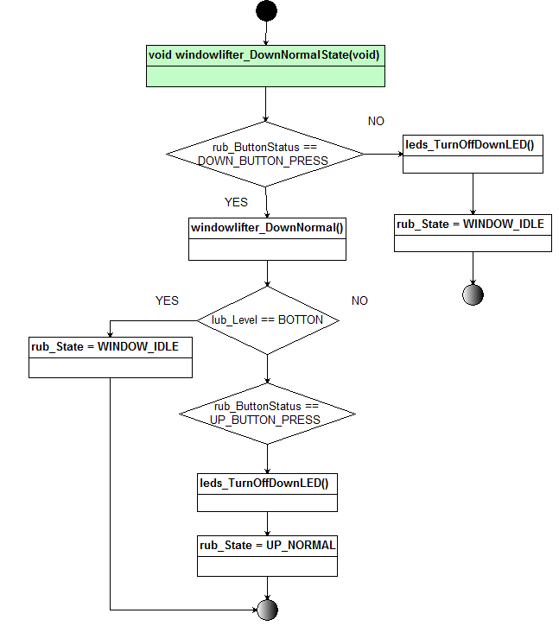

Function void windowlifter_AntipinchState(void) [DSD-6]
Description | This function executes the anti pinch, this is a security action to prevents accidents to the general user.
Parameter 1 | None
Return Value | void
Precondition | Scheduler running, and the window must be running the up movement . buttonsm_StateMachine(void)
Post condition | None
Error Conditions | None

Dynamic Behavior

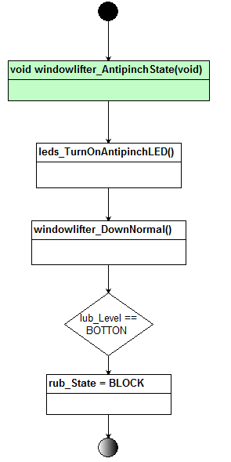

Function void windowlifter_BlockState(void) [DSD-7]
Description | This function executes the a block, this is a security action and makes than the module waits for five seconds completely immobilized until normal operations are restored.
Parameter 1 | None
Return Value | void
Precondition | Scheduler running, and the window doesn´t have movement . buttonsm_StateMachine(void)
Post condition | None
Error Conditions | None

Dynamic Behavior
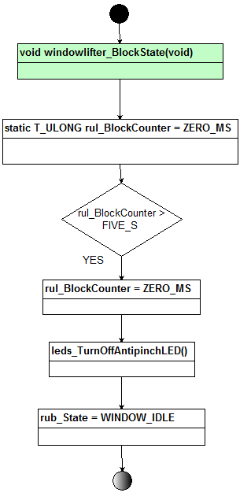

Function void windowlifter_UpNormal(void) [DSD-7]
Description | This function executes the Up function, with the finite state machine running , just if the level have the appropriated conditions to execute the action, and it turns the auxiliary led to specify the movement action.
Parameter 1 | None
Return Value | void
Precondition | Scheduler running,. buttonsm_StateMachine(void)
Post condition | None
Error Conditions | None

Dynamic Behavior

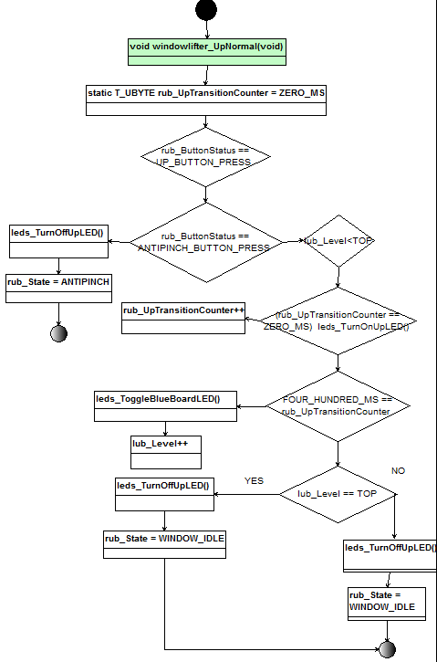

Function void windowlifter_StateMachine(void) [DSD-8]
Description | This function executes the a switch with the cases of each action to can run the finite state machine to complete the window lifter application.
Parameter 1 | None
Return Value | void
Precondition | Scheduler running, buttonsm_StateMachine(void)
Post condition | None
Error Conditions | None

Dynamic Behavior

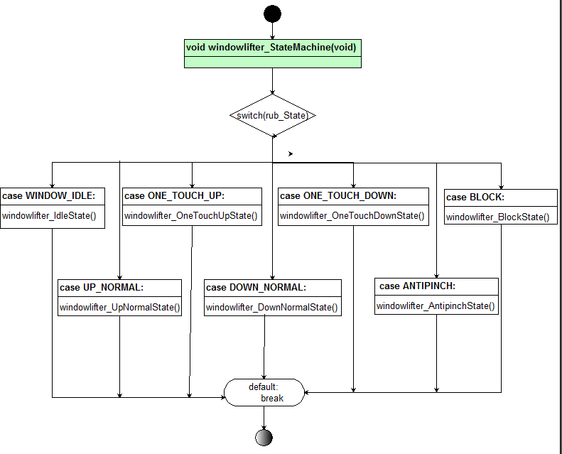

Buttonsm.c

Function void buttonsm_StateMachine(void) [DSD-9]

Description | This function is the representation of each case in the other finite state machine to can operate each case of the options of buttons press, to make the validation of this ones.
Parameter 1 | None
Return Value | void
Precondition | Scheduler running, buttons, and ports, window lifter state machine.
Post condition | Any state in our window lifter application.
Error Conditions | None

Dynamic Behavior

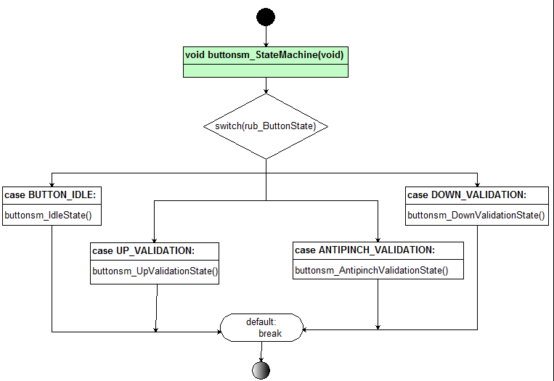

Function void buttonsm_IdleState(void) [DSD-]

Description | This function is the representation of the idle state, this is in case than all the buttons be activated, and waiting for an action of the options of press, to make the validation of the window modality than be required.
Parameter 1 | None
Return Value | void
Precondition | Scheduler running, buttons, and ports, window lifter state machine.
Post condition | Idle state in our application
Error Conditions | None

Dynamic Behavior

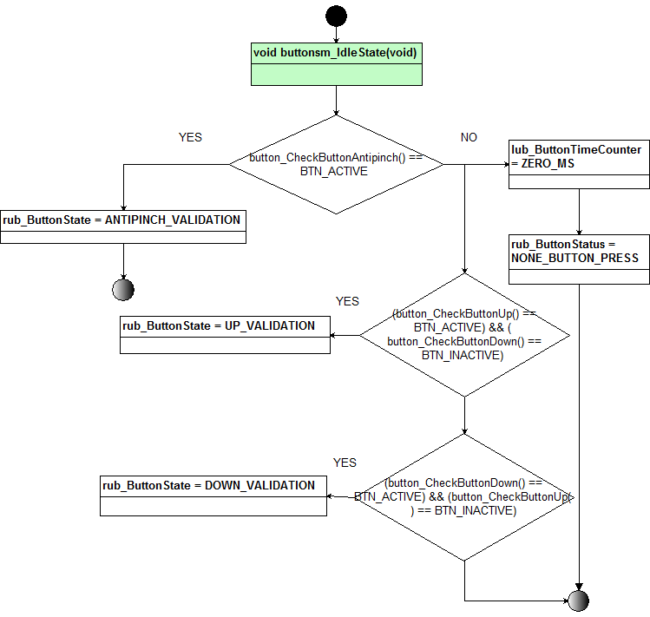

Function void buttonsm_DownValidationState(void) [DSD-10]

Description | This function is the representation of the down validation state, this is in case than the down button be press, and waiting for an action of normal down our one touch, to make the validation of action of movement for the window modality than be required.
Parameter 1 | None
Return Value | void
Precondition | Scheduler running, buttons, and ports, window lifter state machine.
Post condition | Down Normal
Error Conditions | None

Dynamic Behavior

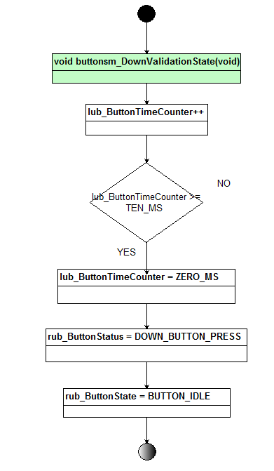

Function void buttonsm_UpValidationState(void) [DSD-11]

Description | This function is the representation of the up validation state, this is in case than the up button be press, and waiting for an action of normal up our one touch, to make the validation of action of movement for the window modality than be required.
Parameter 1 | None
Return Value | void
Precondition | Scheduler running, buttons, and ports, window lifter state machine.
Post condition | Up Normal
Error Conditions | None

Dynamic Behavior

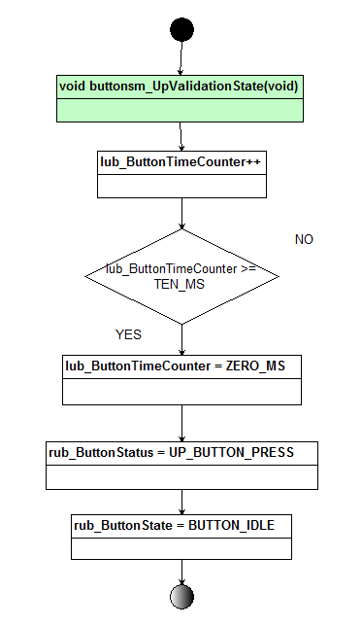

Function void buttonsm_AntipinchValidationState(void) [DSD-12]

Description | This function is the representation of the Antipinch validation state, this is in case than the up movement been executed and the antipinch button be press, and waiting for an action of normal down, to make the security action of movement for the window modality than be required.
Parameter 1 | None
Return Value | void
Precondition | Scheduler running, buttons, and ports, window lifter state machine.
Post condition | Down Normal
Error Conditions | None

Dynamic Behavior

